**Workers’ Leave Microsimulation Dissemination Plan**

**DRAFT Version 4**

This document describes our work plan for disseminating our Workers Leave Microsimulation model, as well as for sharing our research findings with those who will use the tool in practice or those most likely will benefit from the information. In the next sections, we discuss in detail our strategy for disseminating the actual software tools and documentation, as well as our plan for disseminating the research findings. Our team understands that that research findings and tools are most effectively disseminated using multiple vehicles, with face to face interaction as the most effective channel. Our plan will include considerations of the following key elements, organized into six sections below:

1. **Software tools and research products.** Our dissemination includes two primary types of products—a software tool and a portfolio of research findings that come from the tool. This section will identify and discuss the exact form of these products to be disseminated, as well as the advantages and disadvantages of each.
2. **Identification of End users, Their Needs, and Dissemination Channels.**  This section will discuss the end users of our tools and our research products, identifying categories of organizations and individuals will apply these products in their work, and how they will apply them. In addition, it will discus the dissemination channels with which we can attempt to reach each user groups.
3. **Dissemination partners and Communication Strategies.** This section identifies individuals, organizations or networks through whom we can reach the targeted end users.

This section will also discuss the means and strategies with which we can convey usefulness of the tool, as well as the relevant the research outcomes

1. **Dissemination Evaluation.**  This section will discuss the means and strategies with which we will determine whether our dissemination worked, what worked, and what did not work.
2. **Dissemination Work Plan and Schedule.** This section will outline the various stages of dissemination, both for the software and for the initial set of research products.

As requested by the DOL team, our team will contact individuals from the TWG and ask them if they are willing to engage in any of the activities identified in I-V above. We will also ask our partner IWPR to identify additional stakeholders to be engaged in the dissemination process.

1. **Software tools and research products.**
2. **Software Tools**  Our software tools to be disseminated will include the following six options:
3. **Python Package or Executable:** This package contains the Python code, libraries, modules, and GUI needed to use the microsimulation within the Python 2 or Python 3 environment. Modules to be disseminated will include: FMLS data processing module, ACS data processing modules, regression module, imputation modules, ML modules.
4. **R Package:**  This package contains the Python code, libraries, modules, and GUI needed to use the microsimulation within the R environment. Modules to be disseminated will include: FMLS data processing module, ACS data processing modules, regression module, imputation modules, ML modules.
5. **Windows Executable:** This package is a Windows executable file that can run in MS Windows, with no Python or R environment required. This package has no modules.
6. **Technical Documentation:** This document contains a detailed description of the methods, their implementation in Python and R, and all issues encountered during our model development work. It all includes all assumptions and external parameters used in model development.
7. **User Guide:** This is a document that explains how to use our software tool in research, analysis, or policy planning.
8. **Tutorial:** This is a step-by-step walk through of how to use our microsimulation model, with a detailed example in of three area of applications:
   1. *Population analysis:* how to use the microsimulation tool to analyze how a given paid leave policy can affect various groups of workers or employers under current rules.
   2. *Policy cost estimate:* how to use the microsimulation tool to estimate the cost that a given state may incur under current rules or new rules.
   3. *Counterfactual scenarios simulation:* how to use the microsimulation tool to analyze how various paid leave policies can affect various groups of workers, employers in one state, were they to adopt the rules from another state.
9. **Research Products**  Our research products to be disseminated will include the following options:
10. **Policy Briefs or Research Briefs:** These are short, narrowly focused research products designed to highlight a particular aspect of policy, a research problem, or a particular collection of stylized facts or findings that can be explored with further research. They can generally in three categories: population analysis, policy analysis, counterfactual simulations.

Examples of population analyses include:

* + 1. Study the effects of family leave on women of child-bearing age
    2. Simulate workers leave and earnings gap between men and women
    3. Estimate the potential impact of workers leave on dual-income families
    4. Analyze leave taking behaviors for individuals with chronic condition
    5. Analyze any racial/ethnic disparities in leave taking behaviors
    6. Analyze family and child-bearing leave policies for individuals in low-wage occupations
    7. Analyze leave taking behaviors for individuals with disabilities

Examples of policy analyses include:

1. Replicate a previous work on workers or family leave model, say the California family leave model
2. Analyze long term versus short term impact of leave policy
3. Assess the difference of short-duration leave versus long-during leave on behavior
4. Conduct simulation of leave-sharing policies
5. Compare the health effects of paid leave and preventive health care
6. Estimate the relationship between paid leave and population health
7. Estimate the fraction of workers who will take up leave by industry and occupations
8. Determine whether the availability and uptake of leave will affect job continuity, earnings, employment, and career advancement

Examples of counterfactual policy analyses include:

1. Estimate the impact of leave on employment in California by changing eligibility rules.
2. Estimate what it would cost Massachusetts to adopt the California paid leave program
3. **Working Paper Series or Research Papers Series:**  These are full-length publication-quality research papers intended to foster discussion, investigation, and collaboration, with the eventual goal of publication in peer-reviewed journals, field journals, or online dissemination portals. (See Appendix 1 for some examples).
4. **Research Manuscripts:** These are full-length research manuscripts ready to be submitted to a peer-reviewed journal or field journals.

**II. Identification of End users, Their Needs, and Dissemination Channels**

Our team will engage three groups of individuals: DOL team members, TWG members, and partners identified by IWPR as potential candidates as external groups of potential users. We will use the following steps:

**Step 1.** **Identification of potential software users and research users**

*Dissemination Partners:*  Currently we have identified the following groups who might be interested in using our simulation tool.:

* + - 1. State agencies
      2. Non-profit (IWPR or similar entities)
      3. DOL personnel
      4. Academics
      5. Members of TWG
      6. Opinion leaders in the paid leave researchers community
      7. Informal networks and colleagues.

From our literature review, we have identified the following individuals with organizations to be contacted as potential dissemination partners:

| Individuals | Affiliation / Organization | Most recent research on paid leave |
| --- | --- | --- |
| 1. Randy Albelda [Randy.Albelda@umb.edu](mailto:Randy.Albelda@umb.edu) | Center for Women in Politics & Public Policy | Albelda, R., & Clayton-Matthews, A. (2017). Paid Family and Medical Leave: Cost and Coverage Estimates of Three Choices in Massachusetts, Policy Brief. |
| 1. Cary Brown   [Cary.Brown@vermont.gov](mailto:Cary.Brown@vermont.gov) | Vermont Commission on Women | Brown, C., & Elgin, D. J. (2016). Vermont Paid Family and Medical Leave Feasibility Study Report to the Vermont Commission on Women, IMPAQ International |
| 1. Claire Erickson [cmerickson4@wisc.edu](mailto:cmerickson4@wisc.edu) | National Association of Working Women | Dederich, B., Erickson, C., Gross, T., & Ross, M. (2019). Analyzing Paid Family and Medical Leave Insurance in Wisconsin: Possible Costs and Effects. In Workshop in Public Affairs. |
| 1. Melissa Favreault   [mfavreau@ui.urban.org](mailto:mfavreau@ui.urban.org) | Urban Institute | Favreault, M., & Johnson, R. (2018). Paying for Parental Leave with Future Social Security Benefits. Washington, DC: Urban Institute. |
| 1. Feinberg, L. F.   [lfeinberg@aarp.org](mailto:lfeinberg@aarp.org) | AARP | Feinberg, L. F. (2018). Breaking new ground: supporting employed family caregivers with workplace leave policies. AARP Public Policy Inst, 136, 1-28. |
| 1. Angela Rachidi   [Angela.Rachidi@AEI.org](mailto:Angela.Rachidi@AEI.org) | American Enterprise Institute | Gitis, B., & Rachidi, A. (2017). Affordable and Targeted: How Paid Parental Leave in the US Could Work. AEI Paper & Studies. |
| 1. Heather Boushey   [hboushey@americanprogress.org](mailto:hboushey@americanprogress.org) | Center for American Progress | Glynn, S. J., Boushey, H., Berg, P., & Corley, D. (2016). Fast facts on who has access to paid time off and flexibility.  Center for American Progress, April 2016. |
| 1. Sarah Glynn   [sglynn@americanprogress.org](mailto:sglynn@americanprogress.org) | National Council on Family Relations | Glynn, S. J., Eyster, K., & Shabo, V. (2018). An Unmet, Growing Need: The Case for Comprehensive Paid Family and Medical Leave in the United States. |
| 1. Rachel Greszler   [Rachel.Greszler@heritage.org](mailto:Rachel.Greszler@heritage.org) | Heritage Foundation | Greszler, R. (2017). Paid Family Leave: Avoiding a New National Entitlement. Heritage Foundation Backgrounder, (3231), 2018-2027. |
| 1. Pronita Gupta   [pgupta@clasp.org](mailto:pgupta@clasp.org) | Center for Law and Social Policy | Gupta, P., Goldman, T., Hernandez, E., & Rose, M. (2018). Paid Family and Medical Leave is Critical for Low-wage Workers and Their Families. Center for Law and Social Policy. |
| 1. Danielle Lindemann   [djl315@lehigh.edu](mailto:djl315@lehigh.edu) | Center for Women and Work | Lindemann, D., & Britton, D. (2015). Earned Sick Days in Jersey City: A Study of Employers and Employees at. |
| 1. Aparna Mathur   [amathur@aei.org](mailto:amathur@aei.org) | American Enterprise Institute | Mathur, A. (2018) The AEI-Brookings working group report on paid family and medical leave. AEI Report, September 2018. |
| 1. Isabel V. Sawhill [isawhill@brookings.edu](mailto:isawhill@brookings.edu) | Brookings Institution | Mathur, A., Sawhill, I. V., Boushey, H., Gitis, B., Haskins, R., Holtz-Eakin, D., & Waldfogel, J. (2017). Paid family and medical leave: An issue whose time has come. A report of the AEI-Brookings Paid Family Leave Project. Washington, DC: The Brookings Institute and the American Enterprise Institute. |
| 1. Brandon McKoy   [McKoy@njpp.org](mailto:McKoy@njpp.org) | New Jersey Policy Perspective | McKoy, B. (2016). Earned Sick Leave for All Would Help New Jersey’s Workers & Boost its Economy. New Jersey Policy Perspective Policy Brief April 2016. |
| 1. Shilpa Phadke   [sphadke@americanprogress.org](mailto:sphadke@americanprogress.org) | Center for American Progress | Phadke, S., Pedreiro, S., Boesch, D., & Ahmed, O. (2018). Economic Security for Women and Families in New Mexico. Center for American Progress, September 2017. |
| 1. Laura Durso   [ldurso@americanprogress.org](mailto:ldurso@americanprogress.org) | Center for American Progress | Robbins, K. G., Durso, L. E., Frank, J. B., & Schultz, E. (2017). People Need Paid Leave Policies that Cover Chosen Family. Center for American Progress, October 2017. |
| 1. Christopher Ruhm   [cjr6e@virginia.edu](mailto:cjr6e@virginia.edu) | University of Virginia | Ruhm, C. J. (2017). A National Paid Parental Leave Policy for the United States. Driving Growth through Women’s Economic Participation, 107. |
| 1. Anjali Sakaria   [Anjali.Sakaria@bos.frb.org](mailto:Anjali.Sakaria@bos.frb.org) | Federal Reserve Bank of Boston | Sakaria, A., & Tosto, J. (2018). Paid Family and Medical Leave: Impact and Implementation. |
| 1. Shelby Sterling   [ssterling@texaspolicy.com](mailto:ssterling@texaspolicy.com) | Texas Public Policy Foundation | Shelby Sterling, J. D., Quintero, J., & Galyen, M. (2019). The Broad-Based Preemption Spark: Mandatory Paid Sick Leave. |
| 1. Bahira Trask   [bahiratrask@ncfr.org](mailto:bahiratrask@ncfr.org) | National Council on Family Relations | Trask, B. S. (2017). Alleviating the stress on working families: Promoting family-friendly workplace policies. |
| 1. Matt Weidinger   [mweidinger@aei.org](mailto:mweidinger@aei.org) | American Enterprise Institute | Weidinger, M. (2019). Why Paid Leave Does Not Belong in the Unemployment Insurance System. AEI Report May 2019. |
| 1. Katherine Gallagher Robbins | Center for Law and Social Policy | Robbins, K. G., Durso, L. E., Frank, J. B., & Schultz, E. (2017). People Need Paid Leave Policies that Cover Chosen Family. Center for American Progress, October 2017. |
| 1. Heather Boushey [hboushey@equitablegrowth.org](mailto:hboushey@equitablegrowth.org) | Washington Center for Equitable Growth | Boushey, H. (2019). *Unbound: How Inequality Constricts Our Economy and What We Can Do About It*. Harvard University Press. |
| 1. Ben Gitis | American Action Forum | Gitis, B. (2019). The Fiscal Implications of the FAMILY Act: How New Paid Leave Benefits Increase Leave-Taking and Drive Up Estimated Program Costs |
| 1. Jack Smalligan   [jsmalligan@ui.urban.org](mailto:jsmalligan@ui.urban.org) | Urban Institute, Income & Benefits Policy Center | Mudrazija, S., & Smalligan, J. (2019). How Work-Limiting Health Shocks Affect Employment and Income. Urban Institute.pdf |
| 1. Chantel Boyens   [cboyens@ui.urban.org](mailto:cboyens@ui.urban.org) | Urban Institute, Income & Benefits Policy Center | Smalligan, J., & Boyens, C. (2018). Expanding Early Intervention for Newly Ill and Injured Workers and Connections to Paid Medical Leave. |
| 1. Kathy White [white@coloradofiscal.org](mailto:white@coloradofiscal.org) or Chris Stiffler [stiffler@coloradofiscal.org](mailto:%20stiffler@coloradofiscal.org) | Colorado Fiscal Institute | Vasan, T., Stiffler, C., Straka, L., & White, K. (2016). Comparing ColoradoCare. |
|  |  |  |

**Academic Researchers**

In addition to the individuals and organizations listed above, we also identified 46 individual academic researchers who previously published in the 10 areas of paid leave research listed above. These individuals will be contacted as potential dissemination partners.

| Individuals | Institution | Most recent research on paid leave |
| --- | --- | --- |
| 1. Sarah Bana [sarah.bana@gmail.com](mailto:sarah.bana@gmail.com) | University of California at Santa Barbara, Dept. of Economics. | Bana, S., Bedard, K., & Rossin-Slater, M. (2019). *The impacts of paid family leave benefits: regression kink evidence from California administrative data* NBER WP 24438 |
| 1. Kelly Bedard [kelly.bedard@ucsb.edu](mailto:kelly.bedard@ucsb.edu) | University of California at Santa Barbara, Dept. of Economics. | Bana, S., Bedard, K., & Rossin-Slater, M. (2019). *The impacts of paid family leave benefits: regression kink evidence from California administrative data* NBER WP 24438 |
| 1. Maya Rossin-Slater   [mrossin@stanford.edu](mailto:mrossin@stanford.edu) | Stanford University Stanford Health Policy Institute | Bana, S., Bedard, K., & Rossin-Slater, M. (2019). *The impacts of paid family leave benefits: regression kink evidence from California administrative data* NBER WP 24438 |
| 1. Jane Waldfogel [jw205@columbia.edu](mailto:jw205@columbia.edu) | Columbia University, School of Social Work | Bartel, A. P., Rossin‐Slater, M., Ruhm, C. J., Stearns, J., & Waldfogel, J. (2018). Paid family leave, fathers’ leave‐taking, and leave‐sharing in dual‐earner households. *JPAM*, *37*(1), 10-37. |
| 1. Kristin Smith [kristin.smith@unh.edu](mailto:kristin.smith@unh.edu) Mobile: (603) 454-8117 | University of New Hampshire, Carsey School of Public Policy | Smith, K (2019) Support for Paid Family and Medical Leave in New Hampshire , UNH Carsey School of Public Policy Brief |
| 1. Debra Fitzpatrick   [harex004@umn.edu](mailto:harex004@umn.edu) | University of Minnesota Humphrey School of Public Affairs, Center on Women, Gender and Public Policy | Fitzpatrick (2016) Paid Family & Medical Leave Insurance: Options For Designing And Implementing A Minnesota Program |
| 1. Nicolas R. Ziebarth   [nrz2@cornell.edu](mailto:nrz2@cornell.edu) | Cornell University,  Institute of Public Affairs | Pichler, S., & Ziebarth, N. R. (2018). Labor market effects of US sick pay mandates. *Journal of Human Resources*, 0117-8514R2. |
| 1. Laura Dresser [ldresser@wisc.edu](mailto:ldresser@wisc.edu) | University of Wisconsin, Center On Wisconsin Strategy | Dresser, L. and Joel Rogers (2019) The State of Working Wisconsin |
| 1. LeaAnne DeRigne [lderigne@fau.edu](mailto:lderigne@fau.edu) | Florida Atlantic University, Phyllis and Harvey Sandler School of Social Work | DeRigne, L., Dare, P. S., Collins, C., Quinn, L. M., & Fuller, K. (2019). Working US Adults without Paid Sick Leave Report more Worries about Finances. Journal of Social Service Research, 45(4), 570-581. |

**Step 2.** **Identification of how our microsimulation tools and research findings or product is useful to our end users.**

By examining the research previously published, we will develop an understanding of what the models are being used for, and thus we will be able to identify compelling arguments for why users may want to use our tools, our research findings, or research products. Our team conducted a preliminary survey of paid leave research between 2015 and 2019, and identified 67 manuscript-length published works between 2015-2019 covering a diverse range of topics, including the following 10 areas of research:

* + - * 1. **Paid leave and work-family balance:** Shelby Sterling et al (2019), Gates et al (2019), Trask (2017) Arellano (2015)
        2. **Paid leave as a women’s right and workplace issue:** Boris (2018), Fisher et al (2016), Forsyth (2017), Geoghegan (2018), Maume (2016).
        3. **Correlation between paid sick leave and specific outcomes:** use of sick days [DeRigne et al (2018)]; worries and stress [DeRigne et al (2019)]; divorce [Forde (2018)]; mental illness [Goss(2018)]; mortality [Kim(2017)]; poverty [Stoddard-Dare et al (2018)]; use of preventive services [DeRigne et al (2017)]; emergency room visits [Bhuyan et al (2016)]; Illness and injuries [DeRigne et al (2016)]; job postings and labor demand [Dillender & Hershbein (2018)]
        4. **Paid leave for those taking care of aging elderly** [NAS & Schulz et al (2016)]; Feinberg (2018)
        5. **Projected economic cost & impact of paid leave**: Dederich et al (2019), Greenfield et al (2019), Weidinger (2019), Williams (2019), Tsui et al (2018), Mathur (2018), Guo et al (2018), Sakaria & Tosto (2018), Kang et al (2018), Gonzales (2017),, Gitis et al (2017), Mathur et al (2017), Ruhm (2017), Albelda & Matthews (2017, 2016), Greszler (2017), Raabe et al (2016), McKoy (2016), Borwn & Elgin (2016), Hayes (2015,2016), West (2015), Harbour et al (2015),
        6. **Impact of paid leave on specific populations:** on medical residents [Gottenborg et al (2019), , Hariton et al (2018), Mba et al (2018)], on military personnel [Laurita & Molloy (2019)], on individuals with death in the family [Lee et al (2018)]; pre-term infants [Weber et al (2018)]
        7. **Public sentiment on paid leave:** Glynn et al (2018), Horowitz et al. (2017),
        8. **The role of labor unions and paid leave:** Park et al (2019)
        9. **How much paid leave is optimal:** Derigne et al (2018), Sun (2017), ALbelda & Clayton Matthews (2017)
        10. **Importance of paid leave to low-wage workers** Winston et al (2019), Gupta et al (2018), Ruark et al (2015)

These 10 areas of paid leave research contain a wide variety of data and methods used. As shown in **Exhibit XXX**  below, a vast majority of these studies use very old data, with regression as the primary analytic method. We believe that, when offered with a new tool with microsimulation capabilities, the researchers engaged in these research areas will likely be interested in a new tool that can offer useful analytic capabilities and more recent data.

**Exhibit XXX:** Tools and data used in10 areas of recent paid leave research

| **Area of Research** | **Current Tools and Data Used** |
| --- | --- |
| 1. Paid leave and work-family balance | **Meta-analysis/secondary analysis of state surveys** **[**Shelby Sterling et al (2019), Trask (2017), Arellano (2015)**]**  **Semi-Structure Interviews** **[**Gates et al (2019)**]** |
| 1. Paid leave as a women’s right and workplace issue | * **Meta-analysis or secondary analysis of state surveys** **[**Boris (2018), Fisher et al (2016), Forsyth (2017), Maume (2016)**]**, **CPS** [Geoghegan (2018)] |
| 3. Correlation between paid sick leave and specific outcomes | |
| 1. Use of sick days [Derigne et al (2018)] | NLSY (1979) cohort 2014, Regression |
| 1. Worries and stress [Derigne et al (2019)] | NHIS (2015), Regression |
| 1. Divorce [Forde (2018)] | CPS 1988-1998, Regression |
| 1. Mental illness [Goss(2018)] | Meta-analysis/secondary analysis |
| 1. Mortality [Kim(2017)] | NIHS (2002-2012), Regression |
| 1. Poverty [Stoddard-Dare et al (2018)] | NIHS (2015), Regression |
| 1. Emergency room visits [Bhuyan et al (2016)] | NHIS (2012-2014), Regression |
| 1. Illness and injuries [Derigne et al (2016)] | NIHS (2013), Regression |
| 1. Job postings and labor demand | Job postings data, Regression |
| 1. Paid leave for those taking care of aging elderly | Meta-analysis, secondary data analysis, Regression |
| 1. Projected economic cost & impact of paid leave | State data, FMLS data, CPS, , Regression |
| 1. Impact of paid leave on specific populations | National survey, Web-based survey. |
| 1. Public sentiment on paid leave | State and national surveys |
| 1. The role of labor unions and paid leave | NLSY (1997), national and international surveys |
| 1. How much paid leave is optimal | NLSY (1979) , Regression, literature review |
| 1. Importance of paid leave to low-wage workers | Meta-analysis, focus groups, interviews |

**Step 3. Identification of future events that might help increase end user interest in our tools, our research findings, or research products**

Working with the DOL team and our partners, we will identify potential meetings, workshops, conferences, online web events, etc., which have the potential to increase interest in our tools and research products.

**Step 4.** **Identification of ways to involve these end users in our research project**

Working with the DOL team and our partners, we will identify potential early beta testers, workshop

participants, of other interested individuals to be engaged in the last stage of our product development.

**Step 5. Identification of what potential barriers our end users might face in trying to use our tools or products.**

Through our engagement with the early beta testers, workshop participants, of other interested individuals

who are engaged in the last stage of our product development, we can then identify potential barriers to

the use of our tool and research products.

**Step 6 Identification of dissemination channels**

Our team will work with DOL/CEO to identify likely candidates for a set of secure software product dissemination options. We currently have the following options:

* 1. **The Open Source Policy Center** IMPAQ team members have met with Matt Jensen from the American Enterprise Institute, who is also the director of the [Open Source Policy Center](https://www.ospc.org/) (OSPC)—an incubator for a range of open-source modeling projects. The OSPC hosts the Policy Simulation Library (**PSL**), which is a software library of public policy models that satisfy a list of open-sourced criteria, and which come from a range of organizations at different levels of open source sophistication. The OSPC model is roughly as follows: Organizations apply to enter the 12-month incubator program, during which they receive guidance about hosting, version control, promoting a community etc. These models are then hosted on the PSL. However, PSL also hosts models that didn’t go through the incubation program. The PSL currently hosts a paid-family leave cost model, but I was particularly attracted by the point-and-click GUI functionality of their taxbrain model, which is something that I think we could use as a template for our GUI if we decide to go with a web-hosted version. The OSPC hosts a monthly conference of presentations which consist of one longer 30 minute presentation as well as a handful of 5-minute presentations of projects. Matt suggested we might like to present at one of those.
  2. **Interactive workshops**  These can be organized at DOL Headquarters for potential users, or at IMPAQ facilities
  3. **Other channels** Our team will investigate the use of electronic dissemination channels such as websites and social media such as Twitter; and Webinars and videos, plus online publications including Full, Executive Summary and Plain English summary reports of the research, as well as Technical reports related to our development efforts.

**III. Dissemination partners and Communication Strategies.**

*Dissemination Partners:* Working with DOL and our partners, we will identify individuals, organizations or networks through whom we can reach the targeted end users. Currently we have identified the following groups who might be interested in spreading the word about our simulation tool.:

* + - 1. State agencies
      2. Non-profit (IWPR or similar entities)
      3. DOL personnel
      4. Academics
      5. Members of TWG
      6. Opinion leaders in the paid leave researchers community
      7. Informal networks and colleagues

*Communication Strategies:* Working with DOL and our partners, we will identify the means and strategies with which we can convey usefulness of the tool, as well as the relevant the research outcomes. We will identify the best ways our target end users could obtain information about research findings, products, or innovations in health care through various means. We will consider the following two main options:

|  |  |
| --- | --- |
| Broadcast, Print, or Online Media | Personal or Organizational Contact |
| Academic journals | Academic partners |
| Book chapters | Advocacy associations |
| Technical Reports | Informal professional networks |
| Trade magazines | Professional conferences |
| Regular Newspapers | Professional meetings |
| Special interest Newsletters | Workshops and other training venues |
| Interest group List-Serves | TBD |
| DOL, IMPAQ, or IWPR Website | TBD |

**V. Dissemination Plan and Schedule.**

This section will outline the various stages of dissemination, both for the software and for the initial set of research products, but will be on hold until we make further progress with model development. Upon reaching the final beta version, our team will prepare a dissemination work plan similar to the following:

**Dissemination Work Plan**

⯈ Immediate action items, schedule, and persons responsible:

|  |  |  |
| --- | --- | --- |
| Action Items | Timeframe | Individual Responsible |
| Draft Dissemination Plan Version 4 | 11/4/2019 | Minh Huynh |
| Draft Email | 11/4/2019 | Minh Huynh |
| Draft list of Dissemination Partners | 11/4/2019 | Minh Huynh |
| Final Email to be sent | TBD | DOL |
| Workshop Tutorial | 2nd Week of 12/2019 | Minh Huynh |

**References**

1. Albelda, R., & Clayton-Matthews, A. (2016). It’s About Time: Costs and Coverage of Paid Family and Medical Leave in Massachusetts.
2. Albelda, R., & Clayton-Matthews, A. (2017). Paid Family and Medical Leave: Cost and Coverage Estimates of Three Choices in Massachusetts, Policy Brief.
3. Arellano, J. (2015). Don’t Leave US Behind: Problems With the Existing Family and Medical Leave Act, and Alternatives to Help Enhance the Employee Work-Family Relationship in the 21st Century. SAGE Open, 5(2)
4. Bana, S., Bedard, K., & Rossin-Slater, M. (2019). The impacts of paid family leave benefits: regression kink evidence from California administrative data NBER WP 24438
5. Bartel, A. P., Rossin‐Slater, M., Ruhm, C. J., Stearns, J., & Waldfogel, J. (2018). Paid family leave, fathers’ leave‐taking, and leave‐sharing in dual‐earner households. JPAM, 37(1), 10-37.
6. Bhuyan, S. S., Wang, Y., Bhatt, J., Dismuke, S. E., Carlton, E. L., Gentry, D... & Chang, C. F. (2016). Paid sick leave is associated with fewer ED visits among US private sector working adults. The American journal of emergency medicine, 34(5), 784-789..
7. Boris, E. (2018). Getting Paid while Taking Time: The Women’s Movement and the Development of Paid Family Leave Policies in the United States by Megan A. Sholar. *Labor: Studies in Working-Class History*, *15*(1), 123-125. <https://doi.org/10.1215/15476715-4288800>
8. Brown, C., & Elgin, D. J. (2016). Vermont Paid Family and Medical Leave Feasibility Study *Report to the* *Vermont Commission on Women, IMPAQ International, LLC, Washington DC, 2016*
9. Clayton-Matthews, A., & Albelda, R. (2017). Description of the Albelda Clayton-Matthews/IWPR 2017 Paid Family and Medical Leave Simulator Model.
10. Committee on Family Caregiving for Older Adults; Board on Health Care Services; Health and Medicine Division; National Academies of Sciences, Engineering, and Medicine; Schulz R, Eden J, editors (2016). Families Caring for an Aging America. Washington (DC): National Academies Press (US); 2016 Nov 8. 4, Economic Impact of Family Caregiving.
11. Dederich, B., Erickson, C., Gross, T., & Ross, M. (2019). Analyzing Paid Family and Medical Leave Insurance in Wisconsin: Possible Costs and Effects. In Workshop in Public Affairs.
12. DeRigne, L., Dare, P. S., Collins, C., Quinn, L. M., & Fuller, K. (2019). Working US Adults without Paid Sick Leave Report more Worries about Finances. *Journal of Social Service Research*, *45*(4), 570-581. <https://doi.org/10.1080/01488376.2018.1481176>
13. DeRigne, L., Dare, P. S., Collins, C., Quinn, L. M., & Fuller, K. (2019). Working US Adults without Paid Sick Leave Report more Worries about Finances. Journal of Social Service Research, 45(4), 570-581.
14. DeRigne, L., Stoddard-Dare, P., & Quinn, L. (2016). Workers without paid sick leave less likely to take time off for illness or injury compared to those with paid sick leave. *Health Affairs*, *35*(3), 520-527.
15. DeRigne, L., Stoddard-Dare, P., Collins, C., & Quinn, L. (2017). Paid sick leave and preventive health care service use among US working adults. *Preventive medicine*, *99*, 58-62. <https://doi.org/10.1016/j.ypmed.2017.01.020>
16. DeRigne, L., Stoddard-Dare, P., Quinn, L. M., & Collins, C. (2018). How Many Paid Sick Days Are Enough?. Journal of occupational and environmental medicine, 60(6), 481-489.  <https://doi.org/10.1097/JOM.0000000000001300>
17. Dillender, M., Hershbein, B. (2018) Paid Family Leave and Employer Skill Demand: Evidence from Job Postings *W.E. Upjohn Institute for Employment Research, 300 S. Kalamazoo, MI*
18. Dresser, L. and Joel Rogers (2019) The State of Working Wisconsin
19. Favreault, M., & Johnson, R. (2018). Paying for Parental Leave with Future Social Security Benefits. *Washington, DC: Urban Institute*.
20. Feinberg, L. F. (2018). Breaking new ground: supporting employed family caregivers with workplace leave policies. *AARP Public Policy Inst*, *136*, 1-28.
21. Fisher, G. G., Valley, M. A., Toppinen-Tanner, S., & Mattingly, V. P. (2016). Parental leave and return to work. In *Research Perspectives on Work and the Transition to Motherhood* (pp. 129-148). Springer, Cham.
22. Fitzpatrick (2016) Paid Family & Medical Leave Insurance: Options For Designing And Implementing A Minnesota Program
23. Forde, T. S. (2018). For Better, For Worse: The Effect of Maternity Leave Policy on Divorce Rates. (Master Thesis, Hunter College, City University of New York)
24. Forsyth, S. J. Q. (2017). Bringing Up Baby Under the FMLA: How the Federal Unpaid Maternity Leave System in the United States Will Not Carry to Term. *Wm. & Mary J. Women & L.*, *24*, 379.
25. Gates, A. B., Pacheco, D., Mejía, A., Varquez, C., Martínez, E., & Dillard, D. (2019). Exploring Conflicts Between Work and Care: Vulnerable Populations and Paid Family Leave. *Families in Society*, 1044389419863258. <https://doi.org/10.1177/1044389419863258>
26. Geoghegan, F. (2018). The Gender Wage Gap: How Paid Family Leave Affects Women of Childbearing Age, (Master Thesis, Georgetown University).
27. Gitis, B., & Rachidi, A. (2017). Affordable and Targeted: How Paid Parental Leave in the US Could Work. *AEI Paper & Studies*.
28. Glynn, S. J., Boushey, H., Berg, P., & Corley, D. (2016). Fast facts on who has access to paid time off and flexibility.  *Center for American Progress, April* *2016*.
29. Glynn, S. J., Eyster, K., & Shabo, V. (2018). An Unmet, Growing Need: The Case for Comprehensive Paid Family and Medical Leave in the United States.
30. Gonzales, E. (2017). Expand Paid Family and Medical Leave.
31. Goss, M. (2018). The Therapist Can't See You Now: How Paid Sick Leave Policy Can Accommodate Mental Illness in the Workplace. Ark. L. Rev., 71, 969.
32. Gottenborg, E., Rock, L., & Sheridan, A. (2019). Parental Leave for Residents at Programs Affiliated With the Top 50 Medical Schools. *Journal of graduate medical education*, *11*(4), 472-474. <https://doi.org/10.4300/JGME-D-19-00227.1>
33. Greenfield, J. C., Reichman, N., Cole, P. M., & Galgiani, H. (2019). Projected Economic Impacts of Paid Family Leave in Colorado.
34. Greszler, R. (2017). Paid Family Leave: Avoiding a New National Entitlement. *Heritage Foundation Backgrounder*, (3231), 2018-2027.
35. Guo, J., & Zan, H. (2018). Policy Development and Advocacy: The Analysis of a Paid Family Leave Bill in the Hawaii State Legislature. *Social Work & Society*, *16*(1).
36. Gupta, P., Goldman, T., Hernandez, E., & Rose, M. (2018). Paid Family and Medical Leave is Critical for Low-wage Workers and Their Families. *Center for Law and Social Policy*..
37. Harbour, A., Owens, T., Shultz, R., & Weime, N. (2015). Is a National Policy for Paid Parental Leave Possible in the United States?.
38. Hariton, E., Matthews, B., Burns, A., Akileswaran, C., & Berkowitz, L. R. (2018). Pregnancy and parental leave among obstetrics and gynecology residents: results of a nationwide survey of program directors. *American journal of obstetrics and gynecology*, *219*(2), 199-e1. <https://doi.org/10.1016/j.ajog.2018.04.017>
39. Hayes, J. (2015). Final Report on the Costs and Benefits of Paid Family and Medical Leave in the District of Columbia.
40. Hayes, J., & Berlan, M. (2016). Costs and Benefits of Family and Medical Leave for New Hampshire Workers. *IWPR, Washington, DC*.
41. Horowitz et al. (2017), “Americans Widely Support Paid Family and Medical Leave, but Differ Over Specific Policies,” Pew Research Center Report on Paid Leave, 2017.
42. Kang, J. Y., Park, S., Kim, B., Kwon, E., & Cho, J. (2018). The Effect of California’s Paid Family Leave Program on Employment Among Middle-Aged Female Caregivers. *The Gerontologist*.
43. Kim, D. (2017). Paid sick leave and risks of all-cause and cause-specific mortality among adult workers in the USA. International journal of environmental research and public health, 14(10), 1247.
44. Laurita, L., & Molloy, M. (2019). *The Effects of Parental Leave Policy Changes Within the Uniformed Military Services*. (Master Thesis, Naval Postgraduate School, Monterey, CA) Monterey United States.
45. Lee, K. S., Read, D. W., & Markham, C. (2018). The Case for Extending Coverage of the Family and Medical Leave Act to Include a Period of Time Following the Death of a Family Member for Whom Leave Was Taken. Southern Law Journal, 28(1), 27-45.
46. Lindemann, D., & Britton, D. (2015). Earned Sick Days in Jersey City: A Study of Employers and Employees at.
47. Mathur, A. (2018) The AEI-Brookings working group report on paid family and medical leave. *AEI Report, September 2018*.
48. Mathur, A., Sawhill, I. V., Boushey, H., Gitis, B., Haskins, R., Holtz-Eakin, D., & Waldfogel, J. (2017). Paid family and medical leave: An issue whose time has come. A report of the AEI-Brookings Paid Family Leave Project. Washington, DC: The Brookings Institute and the American Enterprise Institute.
49. Maume, D. J. (2016). Can men make time for family? Paid work, care work, work-family reconciliation policies, and gender equality. Social Currents, 3(1), 43-63.
50. Mba, E. H., Matthews, B., Mba, C. A., & Berkowitz, L. R. (2018). Pregnancy and parental leave among obstetrics and gynecology residents: results of a nationwide survey of program directors.
51. McKoy, B. (2016). Earned Sick Leave for All Would Help New Jersey’s Workers & Boost its Economy. New Jersey Policy Perspective Policy Brief April 2016.
52. Park, T. Y., Lee, E. S., & Budd, J. W. (2019). What Do Unions Do for Mothers? Paid Maternity Leave Use and the Multifaceted Roles of Labor Unions. ILR Review, 72(3), 662-692.
53. Pedersen, N. B. (2017). Is More Parental Leave Always Better: An Analysis of Potential Employee Protection for Leave Offered outside the FMLA. *Clev. St. L. Rev.*, *66*, 341.
54. Phadke, S., Pedreiro, S., Boesch, D., & Ahmed, O. (2018). Economic Security for Women and Families in New Mexico. *Center for American Progress, September* *2017*.
55. Pichler, S., & Ziebarth, N. R. (2018). Labor market effects of US sick pay mandates. Journal of Human Resources, 0117-8514R2.
56. Raabe, P. H., & Theall, K. P. (2016). An analysis of paid family and sick leave advocacy in Louisiana: Lessons learned. *Women's Health Issues*, *26*(5), 488-495. <https://doi.org/10.1016/j.whi.2016.07.003>
57. Robbins, K. G., Durso, L. E., Frank, J. B., & Schultz, E. (2017). People Need Paid Leave Policies that Cover Chosen Family. *Center for American Progress, October* *2017*.
58. Ruark, P. (2015). Valuing families, valuing work: Four ways policymakers can help low-paid workers and their children. Working Poor Families Project Policy Brief, July 2015
59. Ruhm, C. J. (2017). A National Paid Parental Leave Policy for the United States. *Driving Growth through Women’s Economic Participation*, 107.
60. Sakaria, A., & Tosto, J. (2018). Paid Family and Medical Leave: Impact and Implementation.
61. Scudder, P. (2018). Failing Our Workers: How the FMLA and RFRA Disadvantage Female Workers in the United States When Compared to Their European Union Counterparts. *Penn St. JL & Int'l Aff.*, *6*, 427.
62. Shelby Sterling, J. D., Quintero, J., & Galyen, M. (2019). The Broad-Based Preemption Spark: Mandatory Paid Sick Leave.
63. Skiba, M. (2016). Barefoot, Pregnant and (Not Very) Happy: Management and Healthcare Reasons for Paid Parental Leave in the US. *Journal of Business Diversity*, *16*(1).
64. Smith, K (2019) Support for Paid Family and Medical Leave in New Hampshire , UNH Carsey School of Public Policy Brief
65. Stoddard-Dare, P., DeRigne, L., Mallett, C., & Quinn, L. (2018). How does paid sick leave relate to health care affordability and poverty among US workers?. *Social work in health care*, *57*(5), 376-392 <https://doi.org/10.1080/00981389.2018.1447532>
66. Sun, K. (2017). Optimal durations of paid family and medical leave to support health (Master Thesis, Boston University).
67. Susser, P., & Ziebarth, N. R. (2016). Profiling the US sick leave landscape.
68. Trask, B. S. (2017). Alleviating the stress on working families: Promoting family-friendly workplace policies.
69. Tsui, E. K., Duffy, M., & Baron, S. (2018). Educating Restaurant Workers About Paid Sick Leave: A Pilot Study From New York City. *NEW SOLUTIONS: A Journal of Environmental and Occupational Health Policy*, *28*(2), 358-377. <https://doi.org/10.1177/1048291118775049>
70. Weber, A., Harrison, T. M., Steward, D., & Ludington-Hoe, S. (2018). Paid Family Leave to Enhance the Health Outcomes of Preterm Infants. *Policy, Politics, & Nursing Practice*, *19*(1-2), 11-28.
71. Weidinger, M. (2019). Why Paid Leave Does Not Belong in the Unemployment Insurance System. *AEI Report May 2019*.
72. West, K. J. (2015). Is the US Missing Out? The Effects of Parental Leave Benefits on Business. *Undergraduate Review*, *11*(1), 120-122.
73. Williams, B. (2019). The Slow Crawl of Paid Family Leave Laws. *California Western Law Review*, *55*(2), 5.
74. Winston, P., Coombs, E., Bennett, R., Antelo, L., Landers, P., & Abbott, M. (2019). Paid family leave: supporting work attachment among lower income mothers. *Community, Work & Family*, *22*(4), 478-511. <https://doi.org/10.1080/13668803.2019.1635436>
75. Zhai, Y., Santibanez, T. A., Kahn, K. E., Black, C. L., & de Perio, M. A. (2018). Paid sick leave benefits, influenza vaccination, and taking sick days due to influenza-like illness among US workers. *Vaccine*, *36*(48), 7316-7323.

**Appendix 1 Examples of Working Papers or Research Papers**

Idea 1:

We propose to improve the imputation of microsimulation model by allowing imputation methods customized to individual simulation steps.

Imputation Implementation in Current Model:

In our current model implementation, users are offer with a list of simulation methods, including regression methods and machine learning methods, as shown in **Exhibit 1** below.

**Exhibit 1: Choices of Simulation Method in Current Model**

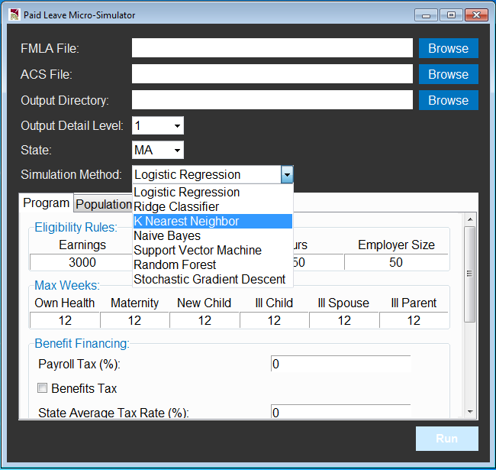

When using the model, the same method chosen will be applied to all simulation steps in the model, including the simulation of:

* Six leave taking variables: *take_own, take_matdis, take_bond, take_illchild, take_illspouse, take_illparent*
* Six leave needing variables: *need_own, need_matdis, need_bond, need_illchild, need_illspouse, need_illparent*
* Indicator of whether worker would respond to new program by increasing leave length: *resp_len*
* Indicators of whether worker sees doctor, and whether stays at hospital: *doctor, hospital*
* Indicators of whether worker receives pay from employer: *anypay*
* Discrete variable of proportion of pay worker receives from employer when taking leave: *prop_pay*

A potential limitation of the above implementation is that the optimal simulation method may not be chosen for *all* simulation steps. For example, Support Vector Machine method can perform better than logistic regression when there are high correlation among predictors (Salazar et al., 2012). On the other hand, SVM can perform worse than logistic regression when there are insufficient number of observations for certain classes, an undesirable situation for deriving the separation the hyperplane. Therefore, SVM can be a good choice of simulation method when the simulation equation involves highly correlated predictors such as education and family income, while its performance can be undermined when we need to simulate a skewed outcome such as *take_illparent* for which over 95% values are zeros in the training (FMLA) sample. Given such possibilities of heterogeneous model performance, in general we would want to allow different simulation methods for different simulation steps.

Proposed Implementation:

The current choices of simulation methods will be preserved - model user can still choose to implement a single method uniformly throughout the entire model. On top of that, in the drop-down list in **Exhibit 1**, we propose to add a “*data-driven method choice*”. Namely, when this option is chosen, the model will rely on the training data (FMLA) to automatically identify the optimal simulation method *for each outcome* to be simulated, and report to user the optimal method identified for each outcome. The optimality of method choice will be determined by a composite score which is a function of a series of model performance metrics computed from cross-validation using the training data - example metrics include *precision*, *recall*, *F1* *score*, *accuracy*, *Area-Under-Curve*, etc. Upon identification of the set of optimal methods that are specific to each simulation step, the optimal methods will be applied accordingly in the model to produce final simulation results. The choice of these optimal methods will be presented to users as runtime message as well as a final log file.

Remarks:

In the final log file, users will also be noted with any low-performance simulation steps - namely, it is possible that even with the optimal method, the performance at certain simulation steps is still not satisfactory, e.g. (i) model performance is not significantly better than random guess when simulating certain outcomes, and (ii) even the best performing model is still inaccurate in simulating certain outcomes. It is crucial to recognize these limitations especially with the small-size FMLA dataset thus any resulting alarming model performance, so that policymakers can base their decisions on model output in the most informed way.

Reference:

Salazar, D. A., Vélez, J. I., & Salazar, J. C. (2012). Comparison between SVM and logistic regression: Which one is better to discriminate?. *Revista Colombiana de Estadística*, *35*(SPE2), 223-237.

Idea 2:

We propose to study time use of leave takers based on simulated leave taking behavior from the microsimulation model.

Data:

BLS Time Use Survey, an annual national sample of ~12,000 workers. Individual workers report their time use on activities include bedtime, providing care to children / elderly / other family members, commuting to work, etc.

Example Use Cases:

Time use can closely measure welfare of leave takers. For example, longer bedtime may leads to better health. More time spent with children can promote better educational outcomes and relationship between household members. Time spent providing care to self / family members can be crucial for medical conditions.

Workflow:

Our microsimulation engine first produces the ACS sample of leave takers that would change their leave taking behavior under a proposed program. We then match the ACS workers with leavers and non-leavers in the ATUS sample, and simulate the time use of ACS workers on work days and leave days.

Microsimulation Engine

Leave Takers (ACS)

Leave Takers

Non-takers

Time Use Data  
(ATUS)

Time Use of Leave Days

Time Use of Non-Leave Days

matching algorithm (e.g. kNN)

Comparisons, Subgroup Analyses, Statistical Tests,…

Since the ACS sample can be identified at state-year level, the time use analysis can also be done for individual states over years. This will provide us a historical comparison of time use in states before and after implementation of paid leave programs. Based on such comparison, we can use time use outcomes to build measures to quantify the welfare implication of these programs. In addition, based on demographic information of workers in the ACS / ATUS sample, subgroup analysis can be performed to focus on welfare improvement on vulnerable worker groups.

Example Application - intra-household spillover effects of paid leave programs

The 4 graphs below comes from an example application using the ACS sample of Massachusetts workers. These are time use histograms. The yellow bars are time use on leave days, and blue bars are for work days. From left to right we have bedtime, and time spent with children. From top to bottom we have the graph for the whole sample, and the lower-wage females. The bedtime results tell us that our model is generating meaningful results that workers can sleep more on leave days than work days. The childcare results on the right suggests the intra-household spillover. Because we restricted the sample to workers taking their own sick leaves, and they are spending more time on another activity which is providing childcare.

Bedtime

Time Spent with Children

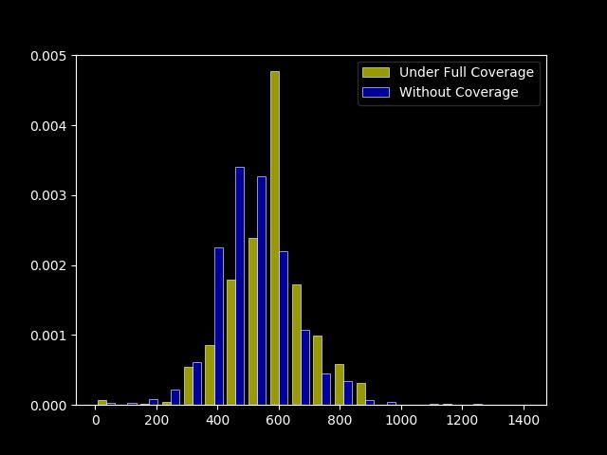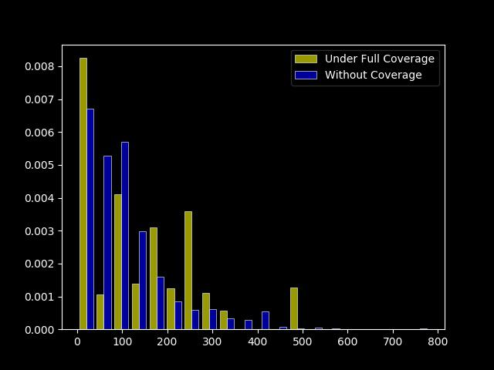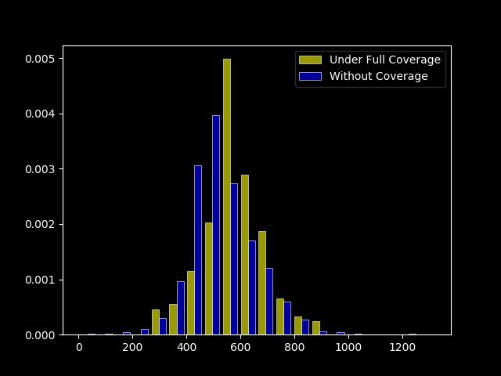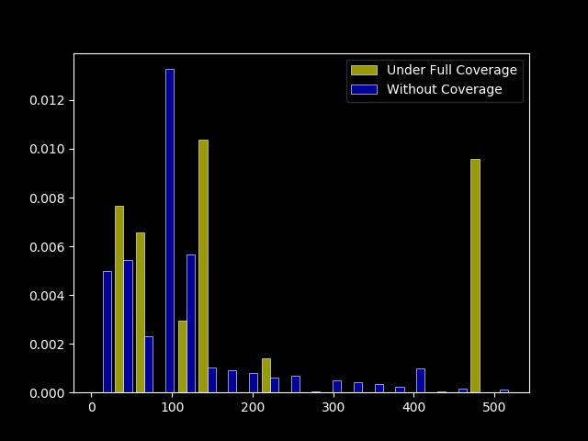

All Workers

Lower-wage Females

[next slide please]